Petite Sirah
Kelsey Bench - Lake County

Estate grown at 1450’ elevation on red, obsidian-strewn soil resulting from Mt. Konocti’s volcanic upheaval and collision with the Mayacamas mountain range, our Petite Sirah is surprisingly delicate and subtle.

Tasting notes: Blackberry and blueberry jam front and center in classic Petite Sirah fashion, but lurking below are black cherry, rose petals, hibiscus, peppery spice blend and a hint of pomegranate. Ample fine-grained gritty Petite cocoa-and-black-tea tannin on the back palate and low acid as is the norm, uncluttered by oak sweetness. Like all Prima Materia wines we are focused more on earth and tactile mouthfeel than soft, oaky fruit and hedonistic beverages.

Vineyard: Planted in 2011, we have only 120 Petite Sirah vines, clone 03 on St. George roots, planted east/west on a 10-degree slope. California sprawl trellising, opting for a circa-1976 style.

Winemaking: Bin fermentations lasting 13 and 16 for both vintages, a little bit of whole cluster, temperatures kept low to minimize tannin extraction. Pressed dirty into barrels and aerated once then returned to barrels and original lees to age.

Vintage: 2016 was quite boring and modest, especially after a bizarre 2015. 2017 was hugely challenging with rain, fire, heat, and lots of disease pressure, but it rewarded those of us who worked extra hard in the vineyard with delicacy, nuance, and layering. This non-vintage blend managed to capture the essence of both.

Label image: Taken from Cabala, published in 1616 by Steffan Michelspacher, it would be hard to find a cooler example of fire-breathing metal dragon art. This image has layers within layers of astronomical, astrological, cosmological and metalurgical becoming, with coded alphabet symbolism, and the general thrust according to the author was “…the degree of exaltation which doth comprehend sublimation and elevation together with distillation.”

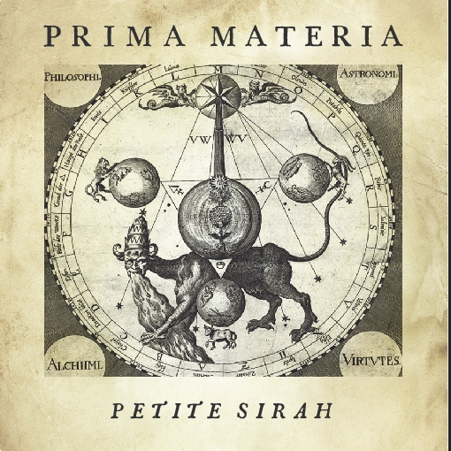

100% Petite Sirah

34% 2016 (one barrel)
66% 2017 (two barrels)
blended in Spring of 2018, then bottled August 2018

3 neutral 225l barrels,
all at least 10 years old

No racking until bottling,
unfined and unfiltered

pH 3.87
TA 5.6gm/l
14.3% abv

72 cases produced

Hand bottled on site

Unreleased at this time,
so no reviews yet

Recommended pairings:
Burgers, grilled meats and veggies, barbacoa, oxtail pasta

SRP $32

