“Arkao” – Carmenére and Cabernet Sauvignon blend, 2013
Dunnigan Hills – Yolo County, Ca.
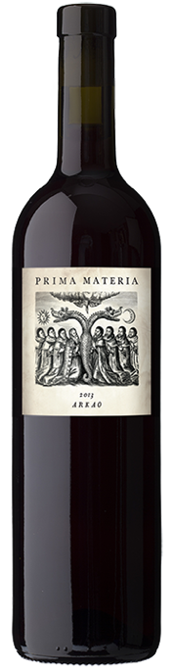
Sadly this is our last vintage of Carménère. After three vintages made from this unique Yolo County vineyard, the vines have been removed, and California has a mere 15 acres of the grape currently. I always enjoyed making this guilty-pleasure of a wine and hope one day it will reappear in our lineup.

Carménère is one of Europe’s most ancient grapes, possibly with Ancient Roman recommendations from the Iberian peninsula, or the Dalmatian Coast depending on who is telling the story, then migrating to Bordeaux quite early. In 1850 it migrated to Northern Italy under the mistaken guise of Cab Franc and then to Chile under the mistaken guise of Merlot during the phylloxera epidemic! One of Cab Franc’s oldest offspring it is a fickle beast though, with clear soil moisture prefercnes, disease susceptibility, narrow ripening requirements, and of course enough pyrazine (bell pepper aroma) to make the eyes water a bit.

The wine: soft, supple, almost creamy. Ratatouille, red pepper and raspberry jam in a cedar bowl. Very low acid, very low tannin. Recommending to drink within a year, though the 2011 vintage is still going strong. 72 cases produced – 2 cases left. Retail price: $35, wine club reorder price $30

Label image: “Arkao” derives from the word “arche” which means beginning and first principle in Greek. The label depicts the descending bird as the breath of God, and the dragon is the complex life force which the breath sets into motion. The scholars seek to learn its secrets which include the spirit of life, both destroying, creating, and many other manifestations.

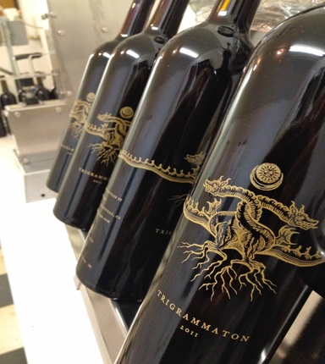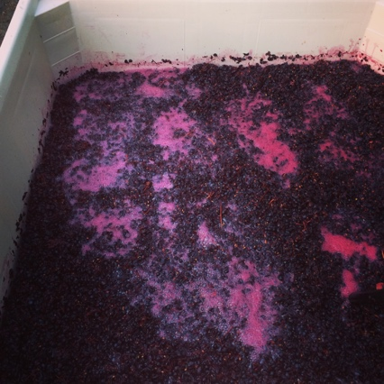

Prima Materia Vineyard & Winery ♦ 482 #B 49th Street, Oakland, Ca. 94609
www.prima-materia.com ♦ info@prima-materia.com

