Nebbiolo, Estate Bottled, Kelsey Bench – Lake County, Ca.
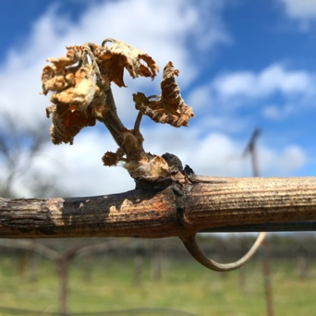
Oh Nebbiolo. That most fickle of grapes. A hundred times more difficult than Pinot Noir in the vineyard, and bizarre in the cellar. Frustrating and maddening in California. We can find a few fun and charming Nebbioli out of the 40 or so California bottlings from diverse, altitude-heavy locations such as Amador, west-side Paso, Mendocino, Santa Barbara, and a couple other places. But profound, Barolo-esque Nebbiolo in California can be counted on only one hand however, and consistency is really nonexistent. Such is the maddening and wonderous nature of Nebbiolo.

We planted 100 of these vines in 2010 and then 300 in 2011. 3 different clones on three different rootstocks were randomized for planting, the exact opposite of our Sangiovese approach. The trellis is extra-tall to manage Nebbiolo’s famous 15’-long canes and crazy growth which never provides enough shade it seems. Fruit thinning and handwork is non-stop. After church, go work your Nebbiolo vines. It is also the first vine to grow in the spring, meaning that it is extremely susceptible to frost, pictured to the left. It is also very late ripening, meaning potential rains and the general risks of a thin-skinned grape surviving weather extremes when only thick-skinned and more durable grapes are still hanging on.

The wine: downright pretty, smelling like Oregon Pinot and Grenache with candied cranberry and marionberry, natural cinnamon plus pepper and medium tannin for Nebbiolo, but still way dry. Acid is medium for this high-strung grape, taking the sting out. This is my 10th vintage of Nebbiolo, and no vintage resembles any other, each one being totally unique unto itself. This is definitely Nebbiolo by way of warmer California, but I get some Barbaresco subtlety and refinement, plus aging potential. This particular bottling is one barrel from 2017, five from 2018, and four from 2019, yielding freshness, fruit, and a bit of age.

Please note: Nebbiolo is considered a wine for aging, and I recommend waiting a few years for the earthy elements to come up and the tannin to polish off. If drinking it now, which is possible, please give it a good decant and open it several hours ahead of time. Despite already spending a year in bottle, the aromas and texture will change dramatically, opening it up and helping move it to a more complete

Label image: Johann Mylius’ Philosophia Reformata from 1622 is a frequent flyer with Prima Materia, also featuring in our Vermentino label. This particular image focuses on multiplication. “Each time the fixed stone is redissolved in the Mercury upon which it feeds, it augments in weight, volume and power. Each rebirth…a tenfold increase in power.“ Retail Price $40

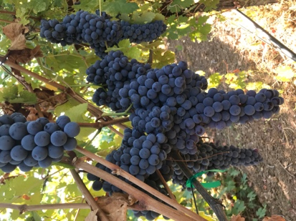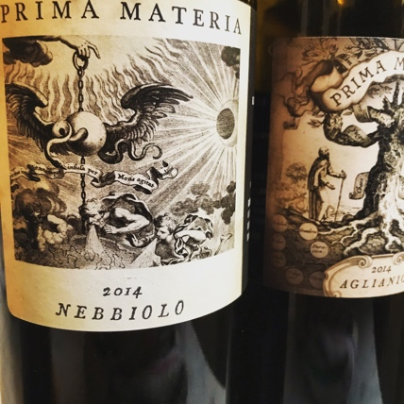

Prima Materia Vineyard & Winery ♦ 482 #B 49th Street, Oakland, Ca. 94609
www.prima-materia.com ♦ info@prima-materia.com

