2020 Vermentino, Red Hills – Lake County, Ca.
This Vermentino is noteworthy for a few backstory reasons.

First: 2020 was just pure chaos. From Covid and the labor crisis to fires burning everywhere, it was a supremely disorienting year. Even the seasonal passage of time – usually a grounding force – seems like a hazy, out-of-control fever dream. I don’t know how we got through it.

Second: I helped the owner by managing all of the picking on this property, absorbing over 1,500 gallons of Petite Sirah, Mourvedre and other bits as his buyers disappeared over smoke concerns and lack of picking crews. And the things is, his property ranges from 20- to 40-degree slopes in big, curving amphitheater overlooking Clear Lake. I almost lost the pickup one day as it slid down gravel toward the lake. We almost lost a backloader too as it slid down the mountain sideways, taking out endposts with the driver screaming bloody murder until it finally stopped on a little dirt swale. I then learned, á la minute, how to drive a crawler tractor when we were out of other options, and realized it was pretty cool climbing out of the row-end bowl and trusting there was dirt below, when I could only see blue-sky ahead on a 40-degree incline. This also meant physically carrying 40-pound tubs up and down the mountain for days. So it was fun, unpaid extra work in an exhausted, crazy, what-next kind of sweaty way.

And third, we talk a lot in these wine notes about how picking decisions determine wine style. Originally we wanted to pick this before the 115-degree Labor Day record-shattering heat hit, planning on a steely, acid-driven lemon laser wine. But, life intervened, and managing the home vineyard took priority naturally, delaying picking by three-plus weeks, and going from that racy citrus zippy white to a more weighty and round medium-bodied wine. Our friends Ryan and Ti helped me finish picking it since the pickers kept leaving early to go pick for their hundreds of other suitors. If ever there was a year to be flexible, 2020 was it.

Label Image: Johann Mylius, accomplished lutist, physician, and author of Philosophia Reformata from 1622, is a frequent flyer here. This particular image is one of a much larger series, but this part is of a smaller block working on fixation. “Every fixation of the Volatile (the fleeing maiden caught by the monster) is followed by a volatilization of the Fixed until Perfection is reached.” Clearly. $24

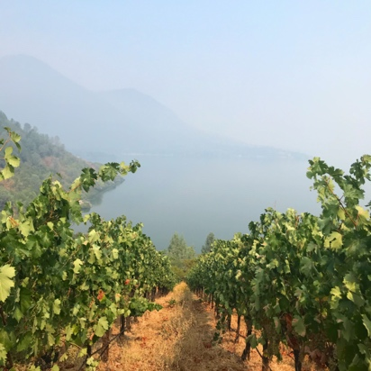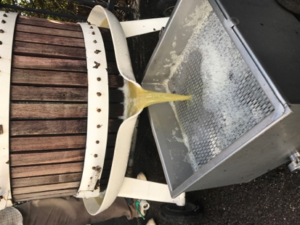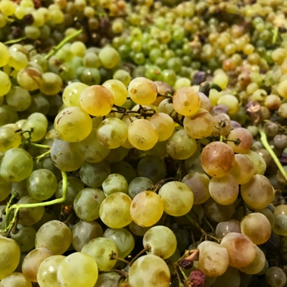

Prima Materia Vineyard & Winery ♦ 482 #B 49th Street, Oakland, Ca. 94609
www.prima-materia.com ♦ info@prima-materia.com

