Sangiovese • 2016
Estate Bottled
Kelsey Bench - Lake County

Grown at 1450’ elevation on red, obsidian-strewn soil resulting from Mt. Konocti’s volcanic upheaval, our Sangiovese combines 4 clones in a focused package that reflects our region while respecting it’s Italian heritage.

Tasting notes: Red-fruit focused with red and black cherry, a bit of floral, bramble and earthiness. Medium acidity and fine-grained appropriate tannins are present. Good minerality. No new oak. Some whole cluster and dried stem inclusion.

Vineyard: Clones include Brunello 06 and Biondi-Santi, Prugnolo Gentile, and Romagnolo VCR 23 on 1103 and 110 roots. Planted in 2010-13 on bilateral cordon utilizing “California sprawl” trellising and varying between north/south and east/west row orientations. Nearly dry farmed. No pesticides. Hand harvested.

Winemaking: All clones hand harvested between 9/5/16 10/02/16. Ferments in bin and tank. All hand punched. Fermentations lasted 12 to 25 days. Wood-basket pressed. No sulfur added for one year, no racking until bottling.

Vintage: Despite a dangerously early bud break, vintage 2016 was almost boring. A bit of early-season shatter and rain occurred but summer was pretty moderate and the fourth year of drought had just enough rainfall to support the crop. August was quite gentle after a few early heat spikes, as was September. It was almost boring compared to super short 2015 and super difficult 2017.

Label Image: Johann Mylius was a composer, physician and ardent alchemist. His Philosophia Reformata was a deep dive into scientific principles. Here the four alchemical sisters sit under the zodiac, each with a color and sign that is a stage in transformation while winds propels them. The metaphor extends neatly into the culinary realm, of which Sangiovese is a famed accomplice.

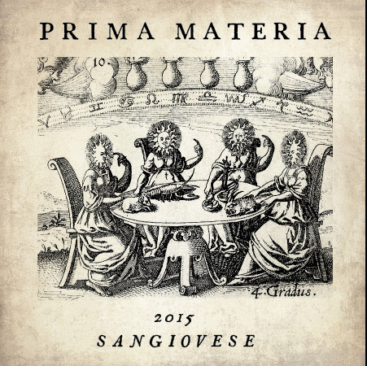

Sangiovese
4 different clones from separate vineyard blocks all fermented separately
8% Aglianico blended in

Yield: 3.0 tons per acre

10 neutral 225l barrels used for aging, mostly old thin stave French and Hungarian oak

No racking until bottling

unfined, unfiltered

pH 3.66
TA 6.0gm/l
14.1% abv

240 cases produced

Hand bottled on site

SRP $25

